Customer Churn Analysis

Objective of the Analysis

The objective of this analysis is to examine customer churn patterns within the bank and identify the key factors that influence customer attrition. By analyzing customer demographics, account information, financial characteristics, and behavioral attributes, the study aims to uncover trends associated with customer churn.
The analysis focuses on understanding how factors such as age, geography, account balance, credit score, product ownership, and customer activity affect the likelihood of a customer leaving the bank. Based on the findings, actionable recommendations are provided to help improve customer retention, enhance customer satisfaction, and support data-driven business decision-making.
Additionally, the analysis explores potential features that can be used in predictive modeling to identify customers at risk of churning, enabling the bank to implement proactive retention strategies and improve overall profitability.

Brief dataset overview

The Customer Churn Dataset contains information on 10,000 bank customers, including demographic, financial, and account-related details. The objective of the dataset is to analyze customer churn behavior and identify factors that influence customers to leave the bank.
The target variable is Exited, where:
- 0 = Customer retained
- 1 = Customer churned
Key features include Age, Geography, Credit Score, Balance, Number of Products, and Customer Activity Status.

Questions and Answers

Question 1: What is the overall customer churn rate in the dataset, and what percentage of customers have exited?
Answer: The overall churn rate is 20.37%.
Insight: Approximately 1 in 5 customers have left the bank, indicating a notable retention challenge
Recommendation: The bank should identify high-risk customer segments and implement targeted retention programs.

Question 2: Which age group exhibits the highest churn rate, and what factors might contribute to this trend?
Answer: Customers aged 50-60 have the highest churn rate.
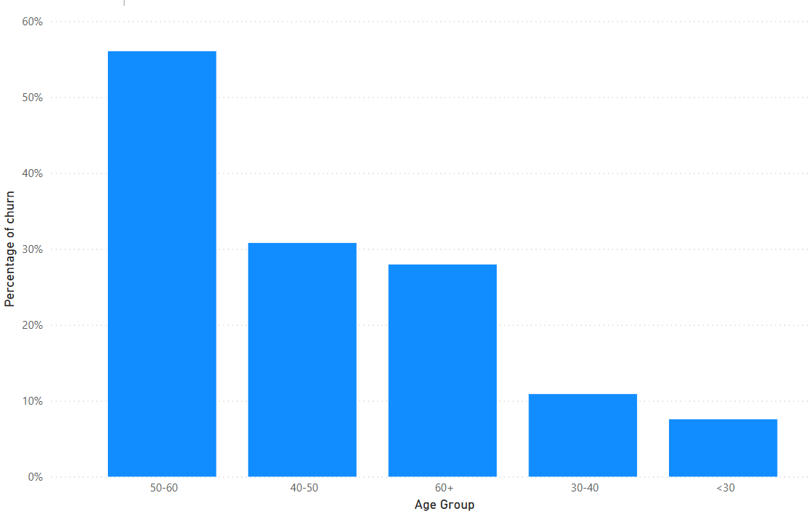
Insight: Older customers may be more willing to switch banks for better financial products.
Recommendation: Introduce loyalty benefits and premium banking offers for this segment.

Question 3: How does customer churn vary across different geographical regions or countries?
Answer: Germany has the highest customer churn rate at 32.44%, while France and Spain have churn rates of approximately 16%.
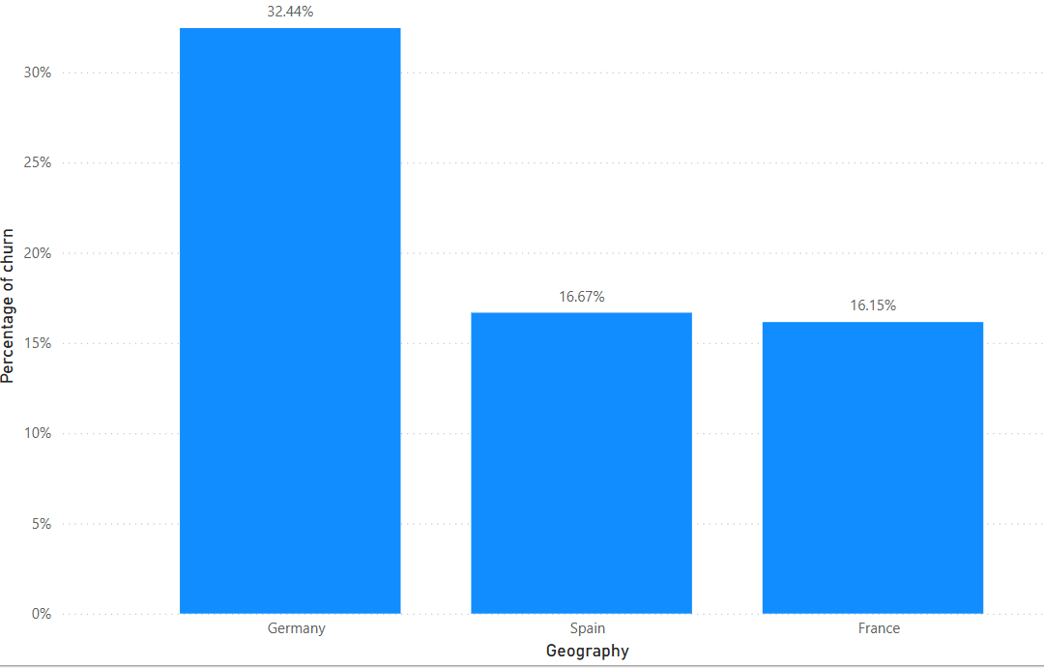
Insight: German customers are leaving the bank at nearly twice the rate of customers in France and Spain
Recommendation: The bank should conduct a detailed investigation into the German market, collect customer feedback, and introduce targeted retention programs for German customers.

Question 4: Is there a relationship between account balance and customer churn? Explain your observations.
Answer: The scatter plot indicates that churn occurs across all balance levels; however, customers with higher account balances appear slightly more likely to churn than customers with very low or zero balances.
Insight: Account balance alone is not a strong predictor of churn, as both retained and churned customers are distributed across the entire balance range. Nevertheless, higher-balance customers represent a valuable segment and their churn can have a greater financial impact on the bank.
Recommendation: The bank should closely monitor high-balance customers and provide personalized services, loyalty benefits, and proactive support to improve retention among this high-value group.

Question 5: How does the number of products owned by a customer influence their likelihood of churning?
Answer: Customers with 4 products exhibit a churn rate of 100% , while customers with 3 products have a churn rate of approximately 83% in contrast, customers with 2 products have the lowest churn rate at around 8%, while customers with product 1 have a churn rate of approximately 28%.
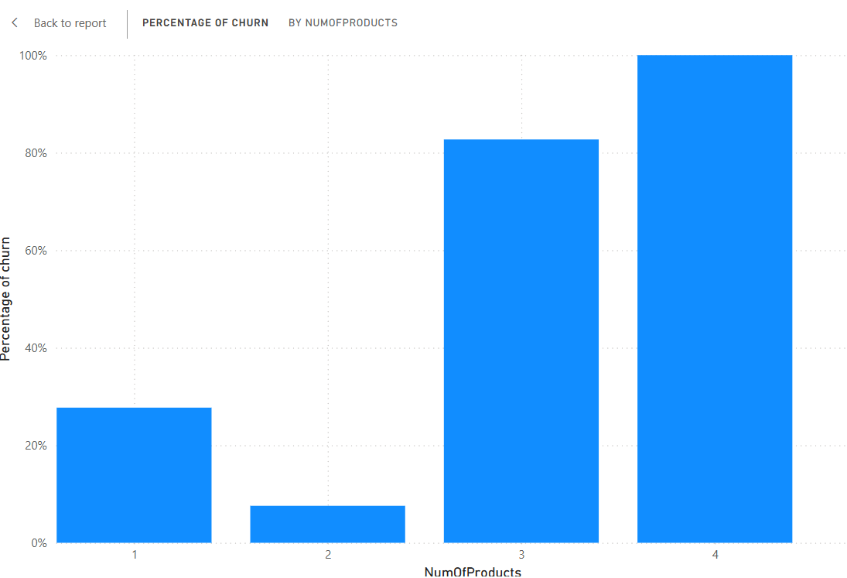
Insight: Although customers with 4 products show complete churn, this result should be interpreted cautiously because the number of customers in this category is very small. Nevertheless, the analysis indicates that customers with 2 products are the most loyal segment.
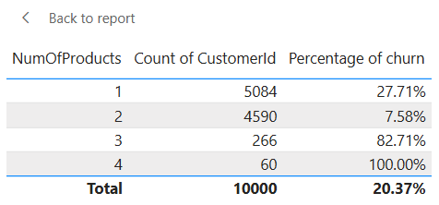
Recommendation: The bank should encourage customers to adopt a second product, as this group demonstrates the strongest retention. Further investigation is needed to understand why customers with 3 and 4 products experience exceptionally high churn rates.

Question 6: Does being an active member have an impact on customer retention? Compare active and inactive customers.
Answer: In this dataset:
Inactive customers (0) have a much higher churn rate.
Active customers (1) have a much lower churn rate.
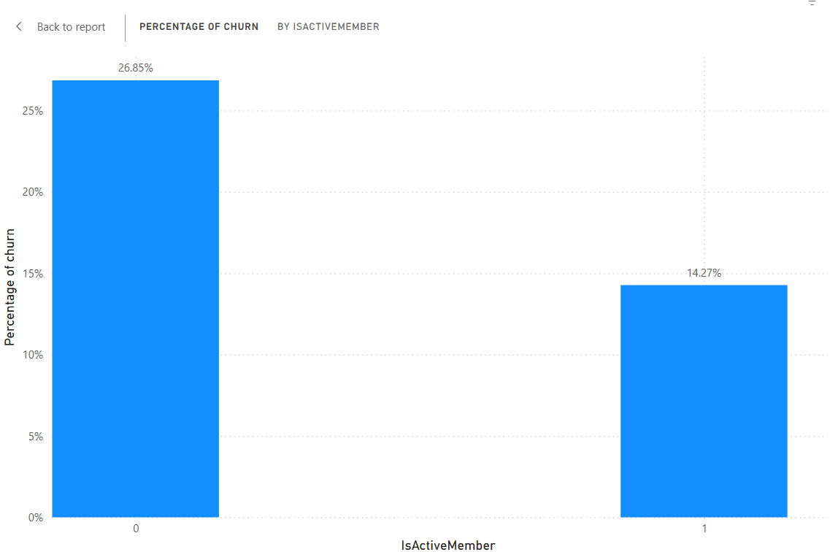
Insight: Customer engagement plays a significant role in retention. Customers who actively use banking services are less likely to leave the bank compared to inactive customers.

Recommendation: The bank should increase customer engagement through personalized offers, digital banking campaigns, loyalty programs, and regular communication to reduce churn among inactive customers.

Question 7: Are there any significant differences in churn behaviour between male and female customers?
Answer: Female customers have a higher churn rate than male customers.

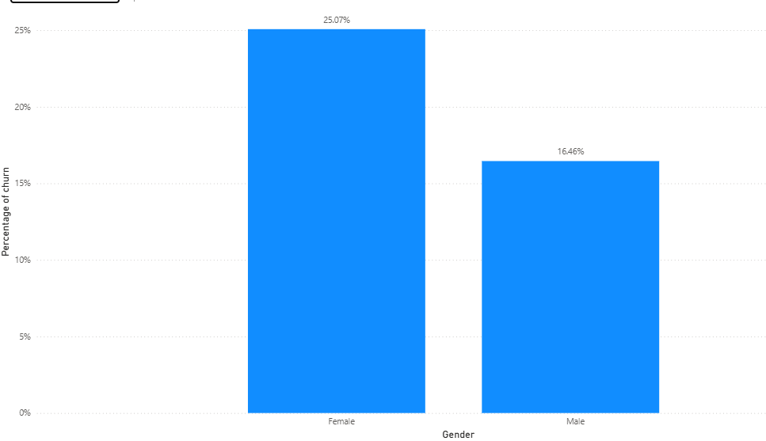

Insight: This indicates that female customers are more likely to leave the bank compared to male customers. The difference may be influenced by customer preferences, satisfaction levels, or banking needs.

Recommendation:
The bank should further analyse the factors contributing to higher churn among female customers and implement targeted retention strategies to improve customer loyalty.

Question 8: How does credit score affect customer churn, and which credit score range shows the highest churn rate?
Answer:
Customers with lower credit scores generally show higher churn rates compared to customers with higher credit scores
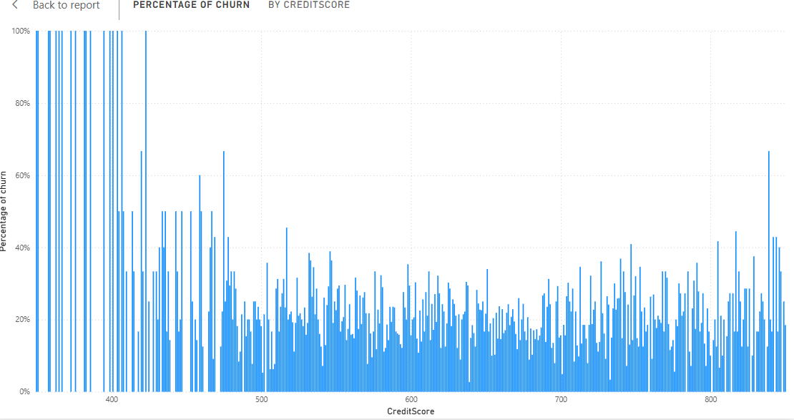

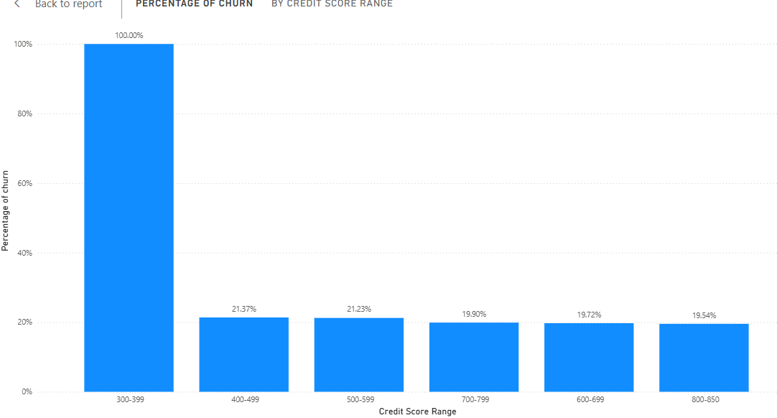
Insight:
Customers with lower credit scores may be more financially vulnerable and therefore more likely to switch banks or discontinue their relationship with the bank.
Recommendation:
The bank should closely monitor customers with lower credit scores and provide personalized financial products, support, and retention programs to reduce churn

Question 9: Based on your analysis, which variables are the strongest predictors of customer churn? Justify your answer.
Answer: The strongest factors associated with customer churn are:
- Age
- IsActiveMember (Customer Activity Status)
- Geography
- NumOfProducts
- Balance
Evidence
Customers aged 50–60 show the highest churn rates.
Inactive customers churn significantly more than active customers.
Germany has a much higher churn rate than France and Spain.
Customers with 3–4 products exhibit extremely high churn rates.
Customers with higher balances generally show higher churn tendencies.

Question 10: If you were managing the bank, what strategies would you recommend to reduce customer churn and improve customer retention?
Answer: The analysis identified higher churn rates among:
- Customers aged 50–60
- Inactive customers
- German customers
- High-balance customers
- Customers with 3 or more products
Recommendations
1. Increase Customer Engagement Inactive customers are more likely to leave the bank. The bank should encourage regular usage through loyalty programs, personalized offers, and digital banking promotions.
2. Implement Targeted Retention Campaigns Customers aged 50–60 and high-risk customer segments should receive personalized retention offers, premium services, and relationship management support.
3. Focus on the German Market Since Germany has the highest churn rate, the bank should investigate customer feedback and introduce market-specific retention strategies.
4. Retain High-Value Customers with high account balances should be offered exclusive benefits, priority support, and personalized financial solutions to improve loyalty.
5. Develop a Churn Prediction System The bank should use customer data to identify customers at risk of leaving and take proactive measures before churn occurs.
Question 11: Which visualization or chart provided the most useful insight, and why?
Answer: The bar chart is the most effective visualization for communicating churn trends.
Reason: It clearly compares churn rates across different customer groups and makes the results easy to understand
Recommendation: The bank can use bar charts to quickly identify customer segments with high churn rates and take appropriate actions.

